**Screenshots:**

Example of responsive web design: we can still see everything in correct sizes on a small screen, code shows the proportions in styles.css for each screeen size

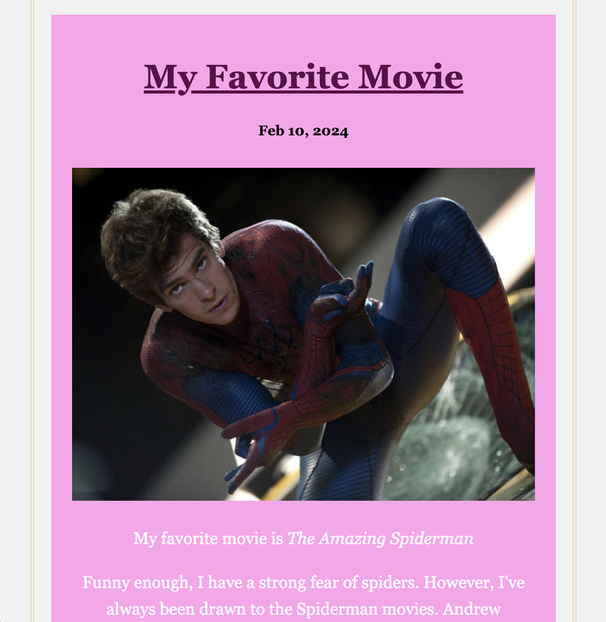

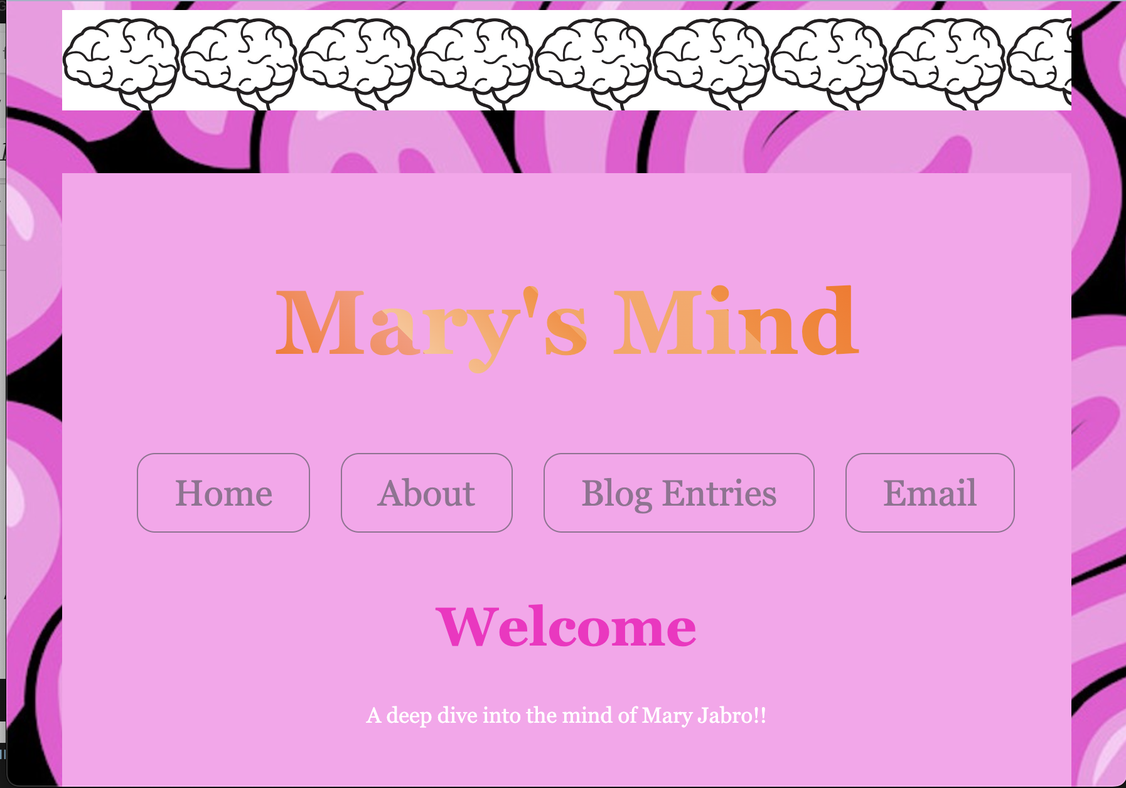

**use of flexbox for the nav**

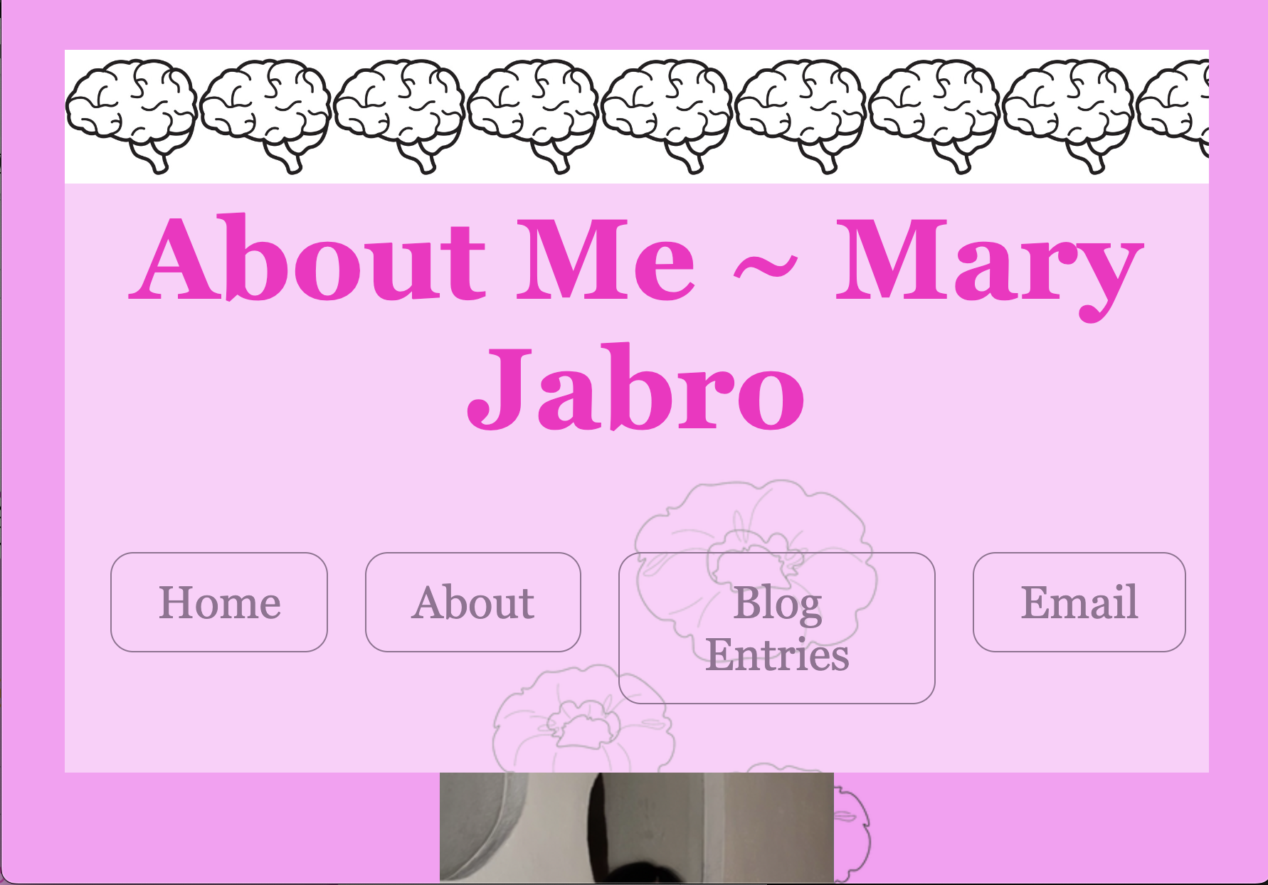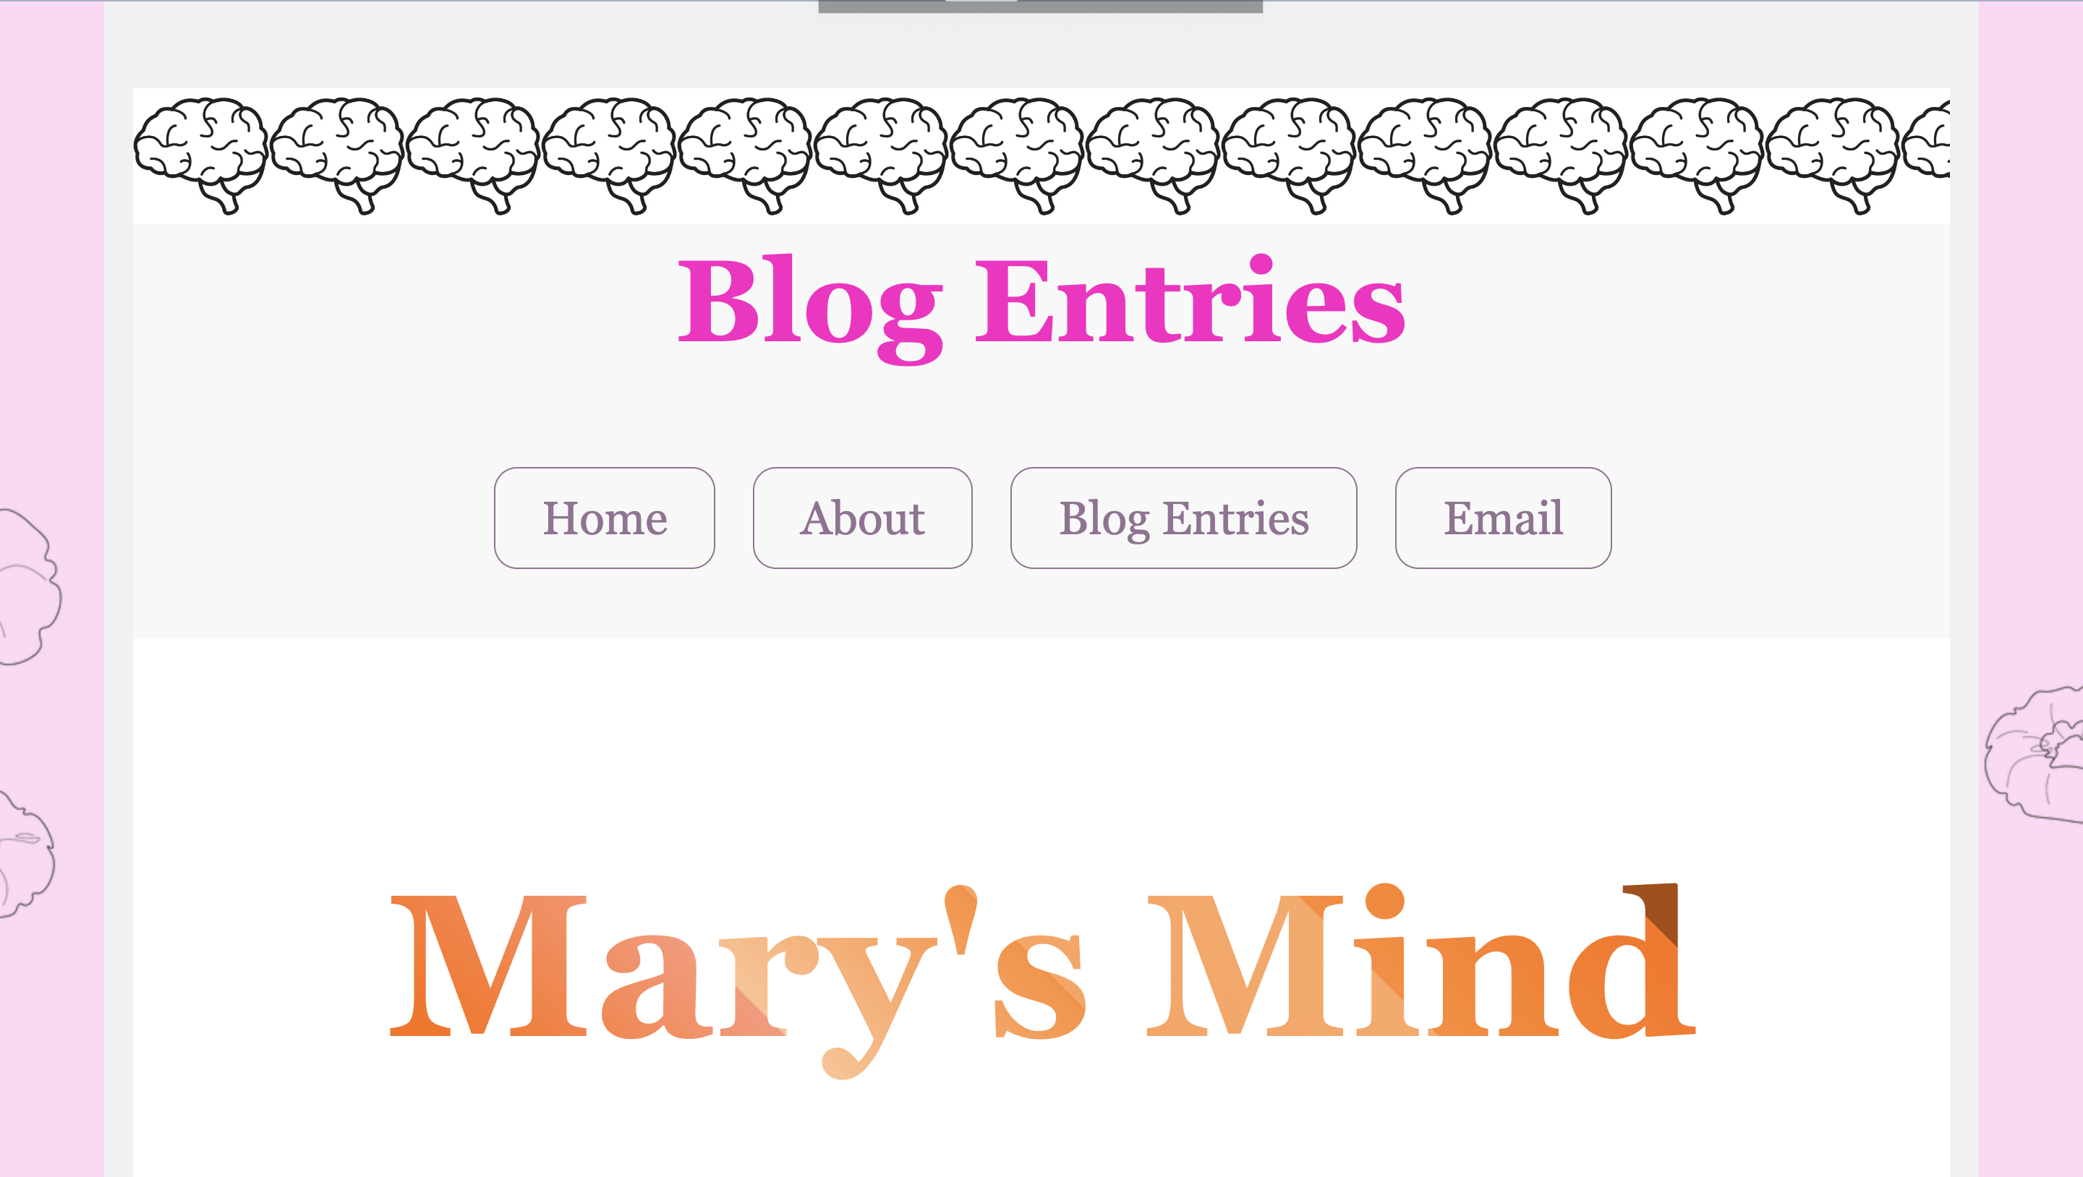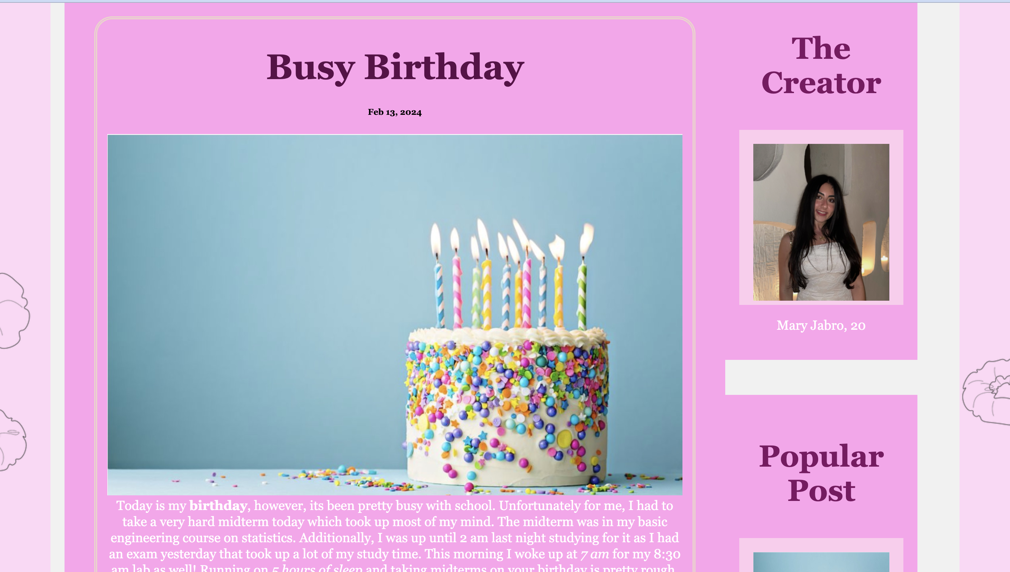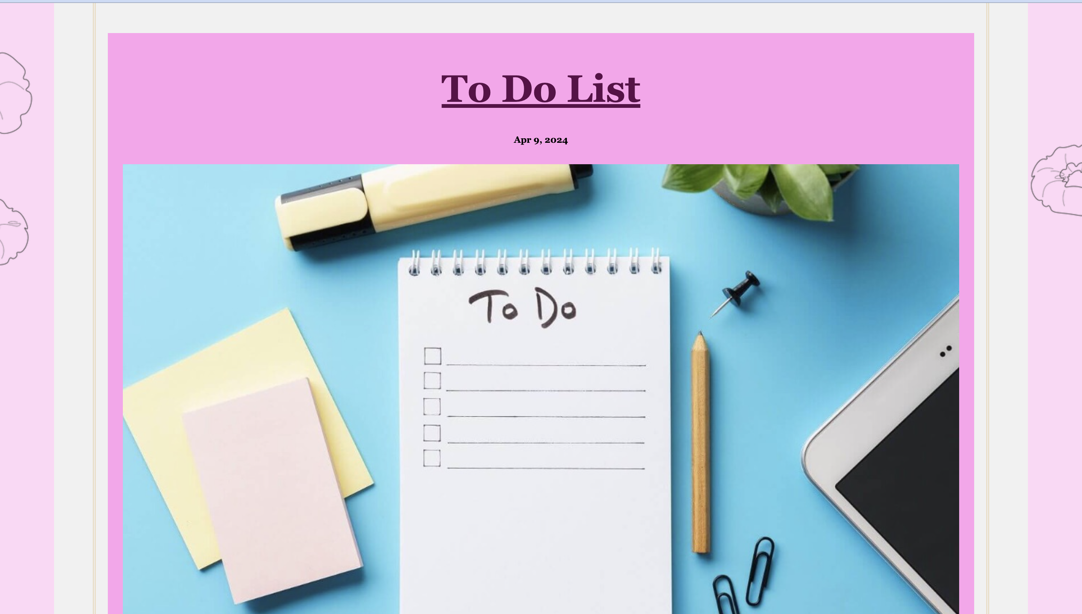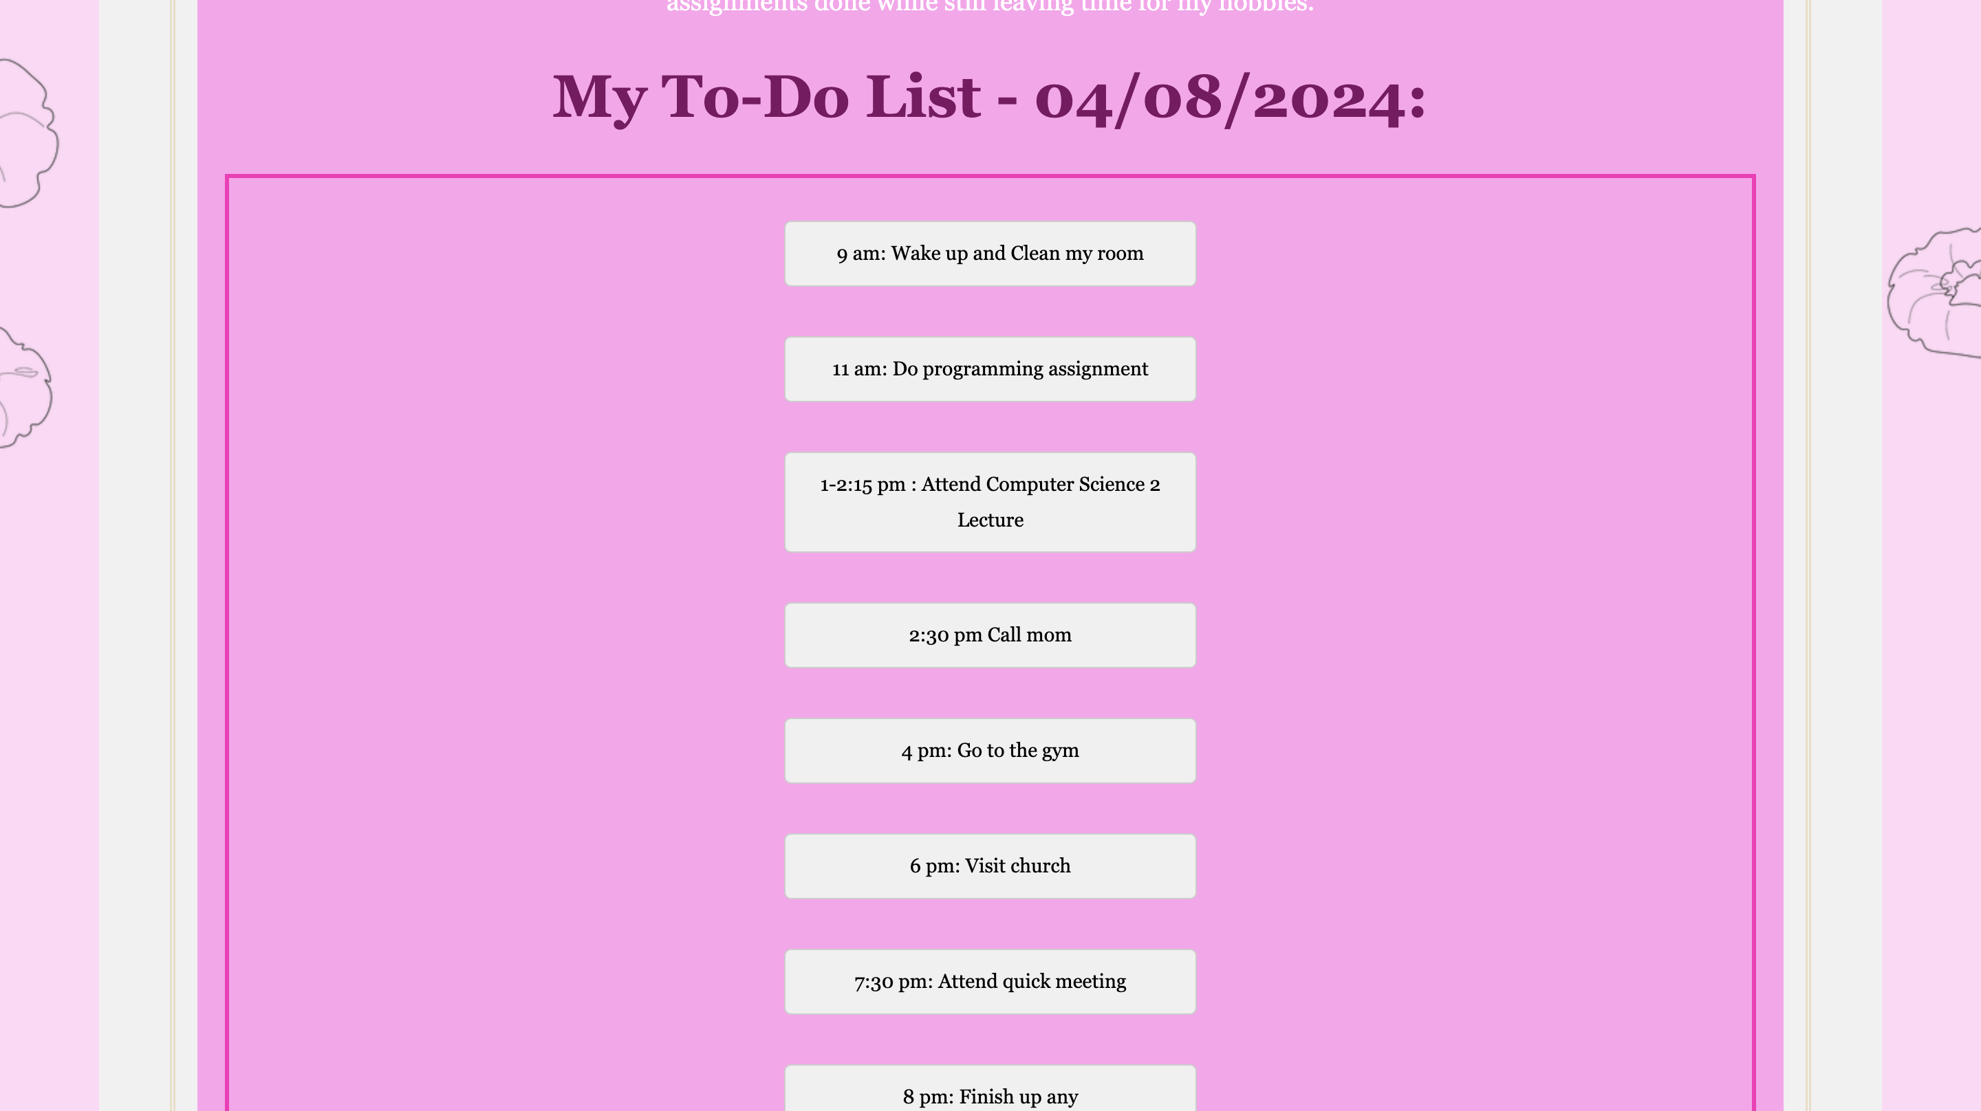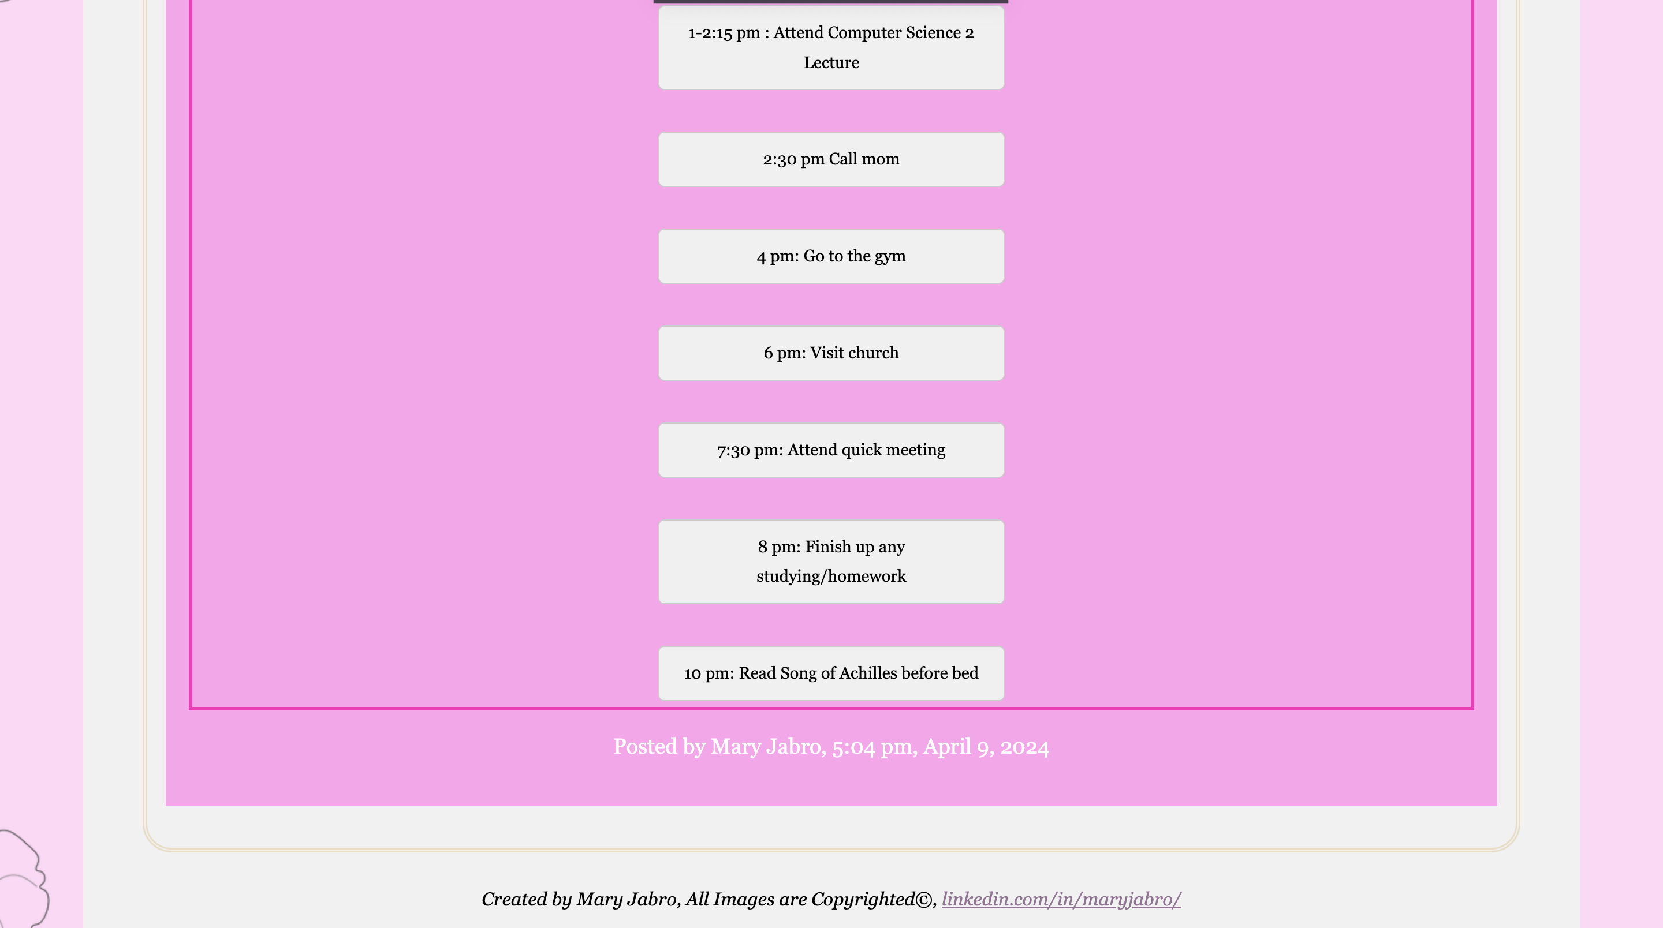

**Flexbox properties for this list formatted in columns**

**Code:**

ADDED/MODIFIED CSS AND HTML ARE HIGHLIGHTED , as requested

Styles.css

.index {

background-color: #e862cb;

background-image: url(background.jpeg);

h2{

color: #fe13c4;

}

h1 {font-size: 5em;

}

.title h1{

background-color: #CA4246;

background-image: linear-gradient(

45deg,

#ff6f00 16.666%,

#ff6f00 16.666%,

#ff9779 33.333%,

#ffc291 33.333%,

#ff8e37 50%,

#ffa25b 50%,

#ffa662 66.666%,

#ff8a2f 66.666%,

#ff6f00 83.333%,

#a94b03 83.333%);

/* Set the background size and repeat properties. */

background-size: 100%;

background-repeat: repeat;

/* Use the text as a mask for the background. */

/* This will show the gradient as a text color rather than element bg. */

-webkit-background-clip: text;

-webkit-text-fill-color: transparent;

font-family: "Marko One", Georgia, serif;

}

}

a {

color: #fe13c4;

text-decoration:none

border-top: 1px solid;

}

a:visited {

color: #937393; /* muted purple for visited links */

}

a:hover,

a:focus,

a:active {

color: #c700f2;

background-color: #fff;

}

header {

margin-top: 0;

padding: 3em 1em 2em 1em;

text-align: center;

background-color: rgba(255,255,255,.5); background-image: url(brainsymbol\ Small.jpeg) ; background-repeat: repeat-x;

background-size: 94px;

margin-top: 2.5em;

}

.blogentries{

background-color: #ffd8f6;

background-image: url(scrunchie.webp);

background-position: center top;

h1{font-size: 5em;}

body{ background-color: #e862cb;

}

* {

box-sizing: border-box;

}

body {

font-family: "Marko One", Georgia, serif;

padding: 20px;

background: #f1f1f1;

}

/* Header/Blog Title */

.header {

padding: 30px;

font-size: 40px;

text-align: center;

background: white;

h2{

background-color: #CA4246;

background-image: linear-gradient(

45deg,

#ff6f00 16.666%,

#ff6f00 16.666%,

#ff9779 33.333%,

#ffc291 33.333%,

#ff8e37 50%,

#ffa25b 50%,

#ffa662 66.666%,

#ff8a2f 66.666%,

#ff6f00 83.333%,

#a94b03 83.333%);

background-size: 100%;

background-repeat: repeat;

-webkit-background-clip: text;

-webkit-text-fill-color: transparent;

font-family: "Marko One", Georgia, serif;}

}

}

.leftcolumn {

float: left;

width: 75%;

}

.rightcolumn {

float: left;

width: 25%;

padding-left: 20px;

}

.fakeimg {

background-color: #ffccee;

width: 100%;

padding: 20px;

}

.card {

background-color: rgb(255, 163, 237);

padding: 30px;

margin-top: 50px;

}

.placeholder img {

max-width: 100%;

height: auto;

}

.row:after {

content: "";

display: table;

clear: both;

}

.CreatorInfo {

padding: 20px;

text-align: center;

background: #485154;

margin-top: 20px;

}

@media screen and (max-width: 800px) {

.leftcolumn, .rightcolumn {

width: 100%;

padding: 0;

}

}

.about{

img.wrap {

float: left;

width: 300px;

height: 300px;

-webkit-shape-outside: url(pacman.png);

shape-outside: url(pacman.png);

-webkit-shape-margin: 1em;

shape-margin: 1em;

}

.largerP{

font-size: 3.5em;

}

h1{

font-size: 5em;

}

background-color: #340329;

background-image: url(scrunchie.webp);

background-repeat: repeat-y;

background-position: right top;

p{

color: #fe13c4;

font-size: 2em;

}

}

.email{

background-color: #ffcbf8;

}

.about{

background-color: #ff9cf5;

}

img {

max-width: 100%;

height: auto;

}

.selection {font-size: 2em;

font-family: "Marko One", Georgia, serif;}

body {

margin: 0 10%;

font-family: 'Times New Roman', Times, serif;

text-align: center;

}

h1 {

font-size: 3em;

color: #fe13c4;

font-family: "Marko One", Georgia, serif;

}

h2 {

font-size: 2.5em;

color: #5c0a48;

font-family: "Marko One", Georgia, serif;}

h3 {

font-size: 2em;

color: #7f0f63;

font-family: "Marko One", Georgia, serif;}

h4 {

font-size: 1.5em;

color: #802e6c;

font-family: "Marko One", Georgia, serif;}

p {

font-size: 1em;

color: #ffffff;

font-family: "Marko One", Georgia, serif;}

section {

margin-bottom: 30px;

}

.selection {

font-size: 2em;

color: #000000;

}

.blogEntry {

color: #000000;

}

table{

margin-left: auto;

margin-right: auto;

td, th {

border: 1px solid #CCC;

}

border: 1px solid black;

}

form {

background-color: lightskyblue;

color: black;

padding: 20px;

font-family: "Marko One", Georgia, serif;}

form, form * {

color: black;

}

td, th { border: 1px solid #CCC; }

table { border: 1px solid black; }

nav ul {

margin: 0;

padding: 0;

list-style-type: none;

display: flex; /* Turn the ul into a Flexbox container */

justify-content: center; /* Center-align the flex items horizontally */

}

nav ul li {

margin: 0.5em;

}

nav ul li a {

display: block;

border: 1px solid;

border-radius: 0.5em;

padding: 0.5em 1em;

text-decoration: none;

color: #fe13c4;

}

nav ul li a:hover {

background-color: #fff;

color: #c700f2;

}

.todo-list {

border: 3px solid #ff26ba;

display: flex;

flex-direction: column;

align-items: center;

justify-content: center;

height: 100vh; /* Full height of viewport */

}

.task {

background-color: #f0f0f0;

border: 1px solid #ccc;

border-radius: 5px;

padding: 10px 20px;

margin: 5px;

width: 300px;

text-align: center;

margin-top: auto;

}

/* Media queries for small screens */

@media screen and (max-width: 600px) {

nav ul li {

flex: none;

width: 100%; /* Set the width of each list item to 100% */

text-align: center; /* Center-align the text */

}

nav ul {

justify-content: center;

padding-left: 0; /* Remove left padding */

}

/* Adjust line height and padding of main content */

article {

line-height: 1.6em;

padding: 1em;

border: double 4px #EADDC4;

border-radius: 25px;

margin: 2.5%;

}

/* Adjust right column width */

.rightcolumn {

width: 50%; /* Adjust width for medium screens */

padding-left: 20px; /* Add left padding */

padding-right: 20px; /* Add right padding */

}

/* Adjust card styles */

.card {

width: 100%; /* Make cards full width */

padding: 20px; /* Add padding to cards */

margin-bottom: 20px; /* Add some spacing between cards */

font-size: 1em; /* Reset font size for cards */

}

body {

margin: 0;

}

h1 {

font-size: 2.5em;

}

h2 {

font-size: 2em;

}

h3 {

font-size: 1.5em;

}

h4 {

font-size: 1.2em;

}

p {

font-size: 1em;

}

}

nav ul {

list-style-type: none;

margin: 0;

padding: 0;

text-align: center; /* Center-align the list items */

}

nav ul li {

display: inline-block; /* Display list items horizontally */

margin-right: 10px; /* Add some space between list items */

}

nav ul li:last-child {

margin-right: 0; /* Remove margin from the last list item */

}

/* Media queries for medium screens */

@media screen and (min-width: 601px) and (max-width: 1024px) {

/* Adjust line height and padding of main content */

article {

line-height: 1.6em;

padding: 1em;

border: double 4px #EADDC4;

border-radius: 25px;

margin: 2.5%;

}

/* Adjust font sizes within cards */

.card {

font-size: 0.9em; /* Adjust font size for cards */

}

body {

margin: 0 5%;

}

h1 {

font-size: 3.5em;

}

h2 {

font-size: 3em;

}

h3 {

font-size: 2.5em;

}

h4 {

font-size: 2em;

}

p {

font-size: 1.2em;

}

}

/* Media queries for large screens */

@media screen and (min-width: 1025px) {

/* Adjust right column width */

.rightcolumn {

width: calc(25% - 20px); /* Adjust width for larger screens considering column gap */

padding-left: 0;

padding-right: 20px; /* Add right padding */

}

/* Adjust line height and padding of main content */

article {

line-height: 1.6em;

padding: 1em;

border: double 4px #EADDC4;

border-radius: 25px;

margin: 2.5%;

}

/* Adjust card styles */

.card {

width: 100%; /* Make cards full width */

padding: 20px; /* Add padding to cards */

margin-bottom: 20px; /* Add some spacing between cards */

font-size: 0.9em; /* Reduce font size for cards */

}

.title{

font-size: 2em;

}

body {

margin: 0 5%;

}

h1 {

font-size: 4em;

}

h2 {

font-size: 3.5em;

}

h3 {

font-size: 3em;

}

h4 {

font-size: 2.5em;

}

p {

font-size: 1.3em;

}

}

Index.html:

<!DOCTYPE html >

<html class= "index">

<head>

<meta charset="utf-8">

<title>Mary's Mind 101</title>

<link rel="stylesheet" href="styles.css">

</head>

<body>

<header> </header>

<div class = "card">

<div class = "title">

<h1>Mary's Mind</h1>

</div>

<div class="selection">

<nav>

<ul>

<li><a href="index.html">Home</a></li>

<li><a href="about.html">About</a></li>

<li><a href="blogentries.html">Blog Entries</a></li>

<li><a href="email.html">Email</a></li>

</ul>

</nav>

</div>

<h2>Welcome</h2>

<p>A deep dive into the mind of Mary Jabro!!</p>

</div>

</body>

</html>

Blogentries.html

<!DOCTYPE html>

<html class="blogentries">

<head>

<title>Blog Entries</title>

<link rel="stylesheet" href="styles.css">

</head>

<body>

<header>

<h1>Blog Entries</h1>

<div class="selection">

<nav>

<ul>

<li><a href="index.html">Home</a></li>

<li><a href="about.html">About</a></li>

<li><a href="blogentries.html">Blog Entries</a></li>

<li><a href="email.html">Email</a></li>

</ul>

</nav>

</div>

</header>

<div class="header">

<h2>Mary's Mind</h2>

</div>

<div class="row">

<div class="leftcolumn">

<div class="card">

<article>

<h2>Busy Birthday</h2>

<h5>Feb 13, 2024</h5>

<div class="placeholder" style="height:500px;"> <img src="birthday.jpeg" alt="birthday cake"></div>

<p>Today is my <b>birthday</b>, however, its been pretty busy with school. Unfortunately for me, I had to take a very hard midterm today which took up most of my mind. The midterm was in my basic engineering course on statistics. Additionally, I was up until 2 am last night studying for it as I had an exam yesterday that took up a lot of my study time. This morning I woke up at <em>7 am</em> for my 8:30 am lab as well! Running on <em>5 hours of sleep</em> and taking midterms on your birthday is pretty rough. However, now that my exams are over, I am glad I can relax and enjoy my birthday.</p>

<p>I turned <b>20</b> today! Which is crazy because I still feel like a teenager. It feels a little bitter sweet turning 20, as I always felt a little negative about growing up. However, I realize I am a year closer to reaching my goals!</p>

<p>I have planned to go to a <em>sushi</em> restaurant for my birthday, my <em>favorite</em> food! Also, I had given up dairy and meat for the first week of lent so sushi may be the only option. Regardless, I am excited.</p>

<div id="sushi order" class="restaurant orders">

<h4>My Sushi Order:</h4>

<ul>

<li>Cucumber Salad</li>

<li>Miso Soup</li>

<li>Rainbow Roll</li>

<li>Spicy Salmon Roll</li>

</ul>

<h4>Wishes</h4>

<p>Before I blew out my candle on my dairy-free ice cream and cupcake, I made sure to wish for health and happiness for myself and those around me for the year.</p>

</div>

</article>

<div id="02/13/24 post" class="blogEntry">

<p>Posted by Mary Jabro, <time datetime="2024-02-13T17:30:00">5:30 pm, February 13, 2024</time></p>

</div>

</div>

<div class="card">

<article>

<h2>Lent</h2>

<h5>Feb 10, 2024</h5>

<div class="placeholder" style="height:500px;"><img src="lent.jpeg" alt="lent"></div>

<p>In my religion, we celebrate <em>lent</em> to which we fast for 40 days from whatever we may choose</p>

<p>I've been brainstorming a list of things I am going to give up and add into my lent this year.</p>

<h4>My Lent:</h4>

<ul id="lent">

<li><b>No</b> meat and dairy during the first week, last week, and on Fridays</li>

<li><b>No</b> music, besides study music</li>

<li><b>No</b> junk food</li>

<li>Give up <em>1</em> social media</li>

<li><em>Add</em> more prayer</li>

</ul>

<p>I chose these things because I know that it will take a lot of discipline to refrain from them. Without struggle, are we really fasting?</p>

<p>A friend once told me&hellip;<br><br> <q>Lent is a Time for<br> Renewing Faith<br> Hope<br> and Love.</q></p>

<div id="02/10/24 post" class="blogEntry">

<p>Posted by Mary Jabro, <time datetime="2024-02-10T19:24:00">7:24 pm, February 10, 2024</time></p>

</div>

</article>

</div>

</div>

<div class="rightcolumn">

<div class="card">

<h3>The Creator</h3>

<div class="fakeimg" style="height:250px;"><img src="me Small.png" alt="mary jabro"></div>

<p>Mary Jabro, 20</p>

</div>

<div class="card">

<h3>Popular Post</h3>

<div class="fakeimg"><img src="birthday.jpeg" alt="birthday cake">Busy Birthday</div><br>

<div class="fakeimg"><img src="lent.jpeg" alt="lent">Lent</div><br>

<div class="fakeimg"><img src="Summer_AmazingSpiderMan.jpg">My Favorite Movie</div>

</div>

<div class="card">

<h3>Contact Me</h3>

<p><a href="https://www.linkedin.com/in/maryjabro/">linkedin.com/in/maryjabro/</a></p>

[<p>maryjabro@wayne.edu</p](mailto:<p>maryjabro@wayne.edu</p)>

</div>

</div>

</div>

<hr>

<article>

<div class="card">

<h2><u>My Favorite Movie</u></h2>

<h5>Feb 10, 2024</h5>

<img src="Summer_AmazingSpiderMan.jpg">

<p>

<p>My favorite movie is <em>The Amazing Spiderman</em></p>

<p>Funny enough, I have a strong fear of spiders. However, I've always been drawn to the Spiderman movies. Andrew Garfield's portrayal of Spiderman has to be my favorite.</p>

<p>Below I have a video of the trailer for reference:</p>

<video src="spidermanTrailer.mp4" width="320" height="262" controls>

Sorry, your browser doesn't support HTML5 video.

</video>

<div id="02/10/24 post" class="blogEntry">

<p>Posted by Mary Jabro, <time datetime="2024-02-10T19:24:00">7:24 pm, February 10, 2024</time></p>

</div>

</p>

</div>

</article>

<article>

<div class="card">

<h2><u>To Do List</u></h2>

<h5>Apr 9, 2024</h5>

<img src="to-do.jpeg">

<p>

A to-do list has helped me layout specific times to do each task that is needed. I like to use these lists as a way to make sure I get all my assignments done while still leaving time for my hobbies.

<h3>My To-Do List - 04/08/2024: </h3>

<div class="todo-list">

<div class="task">9 am: Wake up and Clean my room</div>

<div class="task">11 am: Do programming assignment</div>

<div class="task">1-2:15 pm : Attend Computer Science 2 Lecture</div>

<div class="task">2:30 pm Call mom</div>

<div class="task">4 pm: Go to the gym</div>

<div class="task">6 pm: Visit church</div>

<div class="task">7:30 pm: Attend quick meeting</div>

<div class="task">8 pm: Finish up any studying/homework</div>

<div class="task">10 pm: Read Song of Achilles before bed</div>

</div>

<div id="04/09/24 post" class="blogEntry">

<p>Posted by Mary Jabro, <time datetime="2024-04-10T19:24:00">5:04 pm, April 9, 2024</time></p>

</div>

</p>

</div>

</article>

<footer role="CreatorInfo">

<address>

Created by Mary Jabro, All Images are Copyrighted&copy;, <a href="https://www.linkedin.com/in/maryjabro/" target="_blank">linkedin.com/in/maryjabro/</a>

</address>

</footer>

</body>

</html>

About.html

<!DOCTYPE html>

<html class ="about">

<head>

<title>About Me</title>

<link rel="stylesheet" href="styles.css">

</head>

<body>

<header>

<h1>About Me ~ Mary Jabro</h1>

<div class="selection">

<nav>

<ul>

<li><a href="index.html">Home</a></li>

<li><a href="about.html">About</a></li>

<li><a href="blogentries.html">Blog Entries</a></li>

<li><a href="email.html">Email</a></li>

</ul>

</nav>

</div>

</header>

<section>

<img src="me Small.png" alt="Photo of Mary Jabro">

<br>

<p>

I am...

<ul>

<li>an advocate for health and wellness</li>

<li>a computer geek!</li>

<li>very very curious</li>

<li>an iced coffee addict</li>

</ul>

</p>

<h3>Education</h3>

<picture>

<source media="(min-width: 480px)" srcset="wayne.webp 1200w, wayne.webp 800w" sizes="80vw">

<img src="wayne.webp" alt="Photo of Nintendo Graphic ">

</picture> <p>I am currently attending <em>Wayne State University</em> as a second-year Computer Science Major. </p>

</section>

<section>

<h3>Hobbies</h3>

<h4>Painting</h4>

<p>I love to do <b>art!</b> These are just a few of my paintings</p>

<img src="flamegirl Small.png" alt="Photo of Flame girl Art">

<img src="pokemon Small.png" alt="Photo of Pokemon Art">

<br>

<img src="rick Small.png" alt="Photo of Rick and Morty Art">

<img src="spiderman Small.png" alt="Photo of SpiderMan Art">

<br>

<h4>Exercise</h4>

<p><b>Working out</b> one of my <em>biggest</em> hobbies.</p>

<img src="exercise Small.png" alt="Photo of exercise">

<meta charset="UTF-8">

<meta name="viewport" content="width=device-width, initial-scale=1.0">

<title>Table</title>

</head>

<body>

<table>

<caption>Time to complete Workouts</caption>

<span>

<tr>

<th rowspan="2"></th>

<th colspan="2">Split</th>

<th rowspan="2">Total Time (min)</th>

</tr>

<tr>

<th>Legs</th>

<th>Arms</th>

</tr>

</span>

<span>

<tr>

<th scope="row">Monday</th>

<td>60 min </td>

<td>0 min</td>

<td>60 min</td>

</tr>

<tr>

<th scope="row">Wednesday</th>

<td>0 min</td>

<td>60 min</td>

<td>60 min</td>

</tr>

<tr>

<th scope="row">Friday</th>

<td>45 min</td>

<td>30 min</td>

<td>75 min</td>

</tr>

</span>

</table>

<br>

<h4>Games</h4>

<div class = largerP> <img src="pacman.png" class="wrap" id="pacman-image"><b>Playing video games</b> has been a hobby of mine for as

long as I can remember!

</div>

<picture>

<source media="(min-width: 480px)" srcset="nintendo.avif 1200w, nintendo.avif 800w" sizes="80vw">

<img src="nintendo.avif" alt="Photo of Nintendo Graphic ">

</picture>

<picture>

<source media="(min-width: 480px)" srcset="xbox.jpeg 1200w, xbox.jpeg 800w" sizes="80vw">

<img src="xbox.jpeg" alt="Photo of Xbox Graphic ">

</picture>

<br>

</section>

<footer role="CreatorInfo">

<address>

Created by Mary Jabro, All Imaged are Copyrighted&copy;, <a href="https://www.linkedin.com/in/maryjabro/">linkedin.com/in/maryjabro/</a>

</address>

</footer>

</body>

</html>

Email.html

<!DOCTYPE html>

<html class = "email">

<head>

<meta charset="utf-8">

<title>Email List</title>

<link rel="stylesheet" href="styles.css">

</head>

<body>

<header>

<h1>Email List</h1>

<div class="selection">

<nav>

<ul>

<li><a href="index.html">Home</a></li>

<li><a href="about.html">About</a></li>

<li><a href="blogentries.html">Blog Entries</a></li>

<li><a href="email.html">Email</a></li>

</ul>

</nav>

</div>

</header>

<main role="main">

<form class="emailList" method="POST">

<fieldset>

<legend><b>Join our email list</b></legend>

<p>

Get updates about my future blog posts right after they're published!

</p>

<p>

<label for="firstlast"><b>Name:</b></label>

<input type="text" name="fullname" id="firstlast">

</p>

<p>

<label for="email"><b>Email:</b></label>

<input type="text" name="email" id="email">

</p>

<p>

<label for="phone"><b>Phone Number:</b></label>

<input type="text" name="phone" id="phone">

</p>

<p>

<label>

<b>Send a photo to be used as your online icon for our messaging list <em>(optional)</em></b><br>

<input type="file" name="photo">

</label>

</p>

<fieldset>

<legend><b>Age</b></legend>

<select name="Age" size="1">

<option>17 and younger</option>

<option>18-25</option>

<option>26-34</option>

<option>35+</option>

<option>Prefer not to say</option>

</select>

</fieldset>

<fieldset>

<legend><b>Preferences</b></legend>

<p><b>Check all that apply:</b></p>

<p>

<input type="checkbox" name="Agreement" value="voice_mail">I opt in to receiving voice mails for updates on Mary's Mind Blog Posts

</p>

<p>

<input type="checkbox" name="Agreement" value="promotional">I opt in to receiving promotional marketing messages from partnered companies

</p>

<p>

<input type="radio" name="Agreement" value="recurring_messages">By signing up, you agree to receive recurring automated promotional and personalized messages from Mary's Mind 101 at the call number and email used when signing up.

</p>

</fieldset>

<p><input type="submit" value="Submit"></p>

</fieldset>

</form>

<footer role="CreatorInfo">

<address>

Created by Mary Jabro, All Imaged are Copyrighted&copy;, <a href="https://www.linkedin.com/in/maryjabro/">linkedin.com/in/maryjabro/</a>

</address>

</footer>

</body>

</html>